Getting Started with Amazon Simple Notification Service

Step 1: Open SNS
- Go to AWS Console
- Search for SNS
- Click Amazon Simple Notification Service

🔹 Step 2: Create a Topic
- Click Topics
- Click Create topic
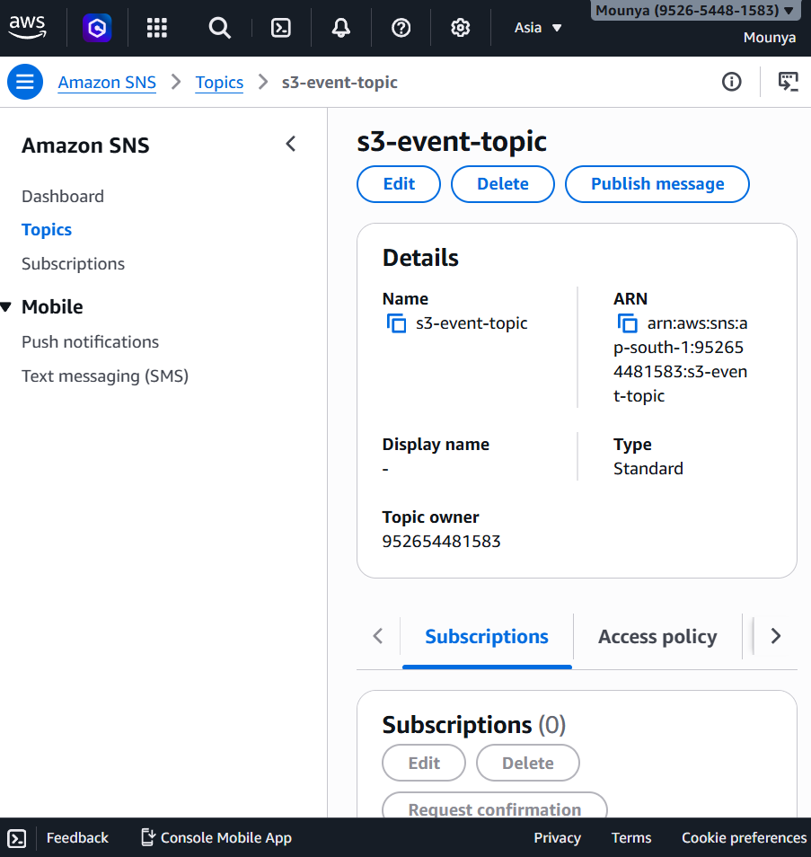

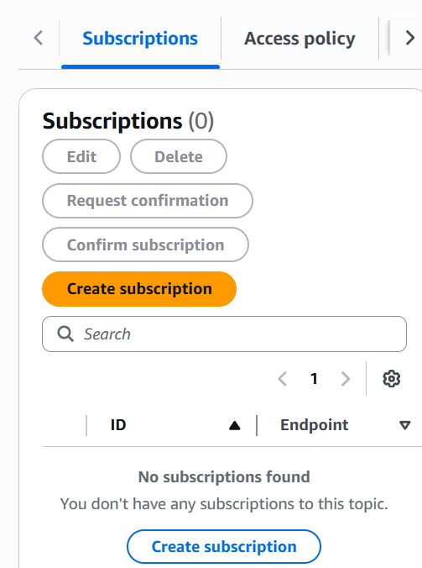
Step 3: Add Subscription
- Open your topic → s3-event-topic
- Click Create subscription
Confirm the Email (IMPORTANT)
📩 Check your email inbox
You will receive a message from AWS.
- Open it
- Click Confirm subscription
✅ Status will change to Confirmed
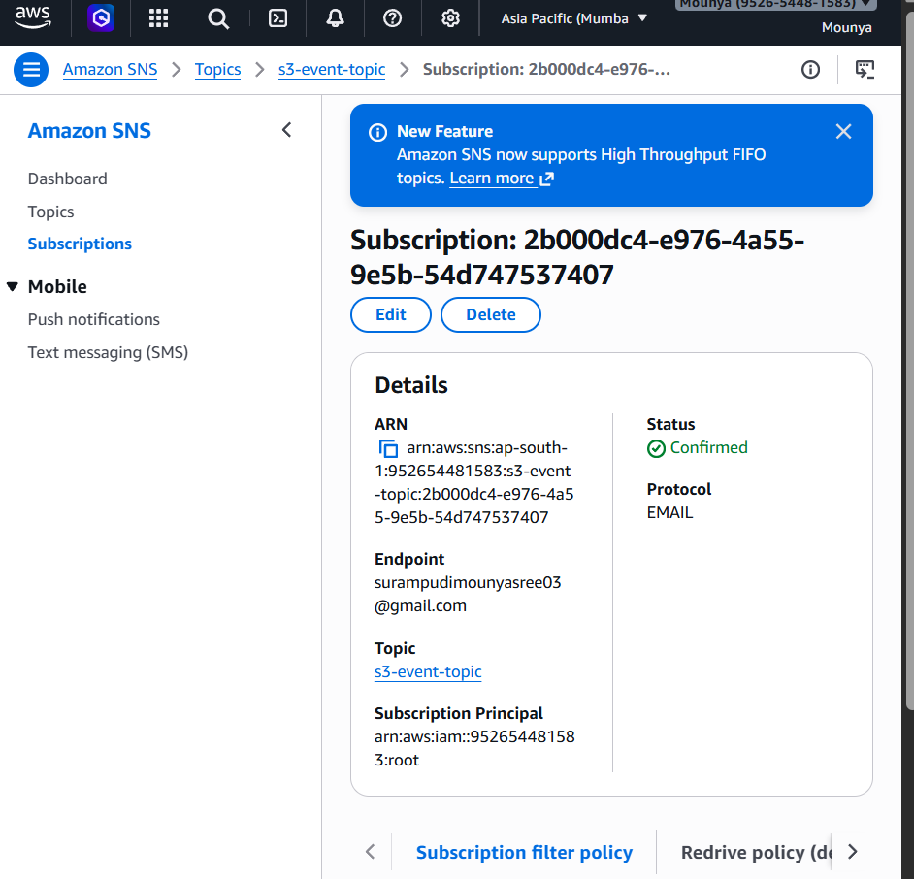

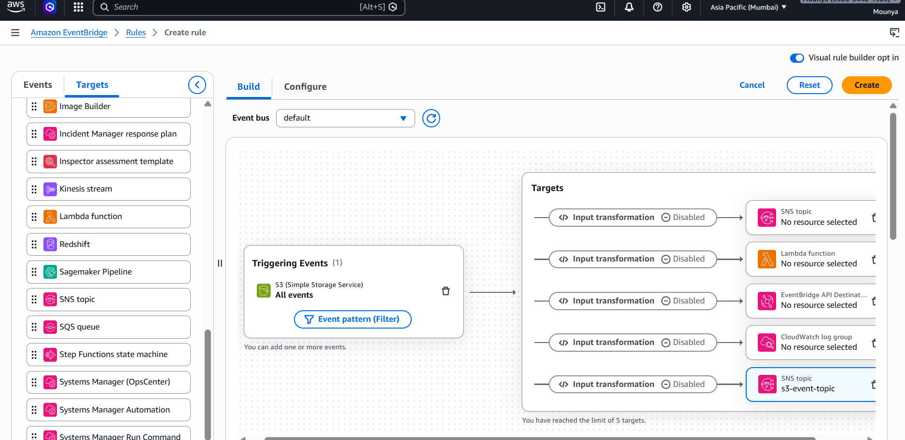

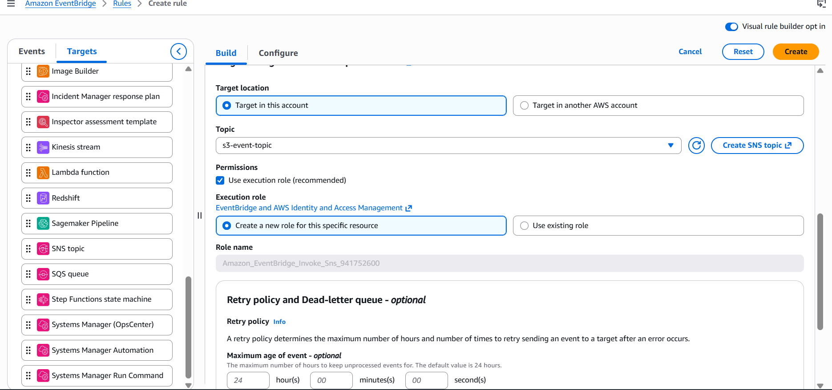

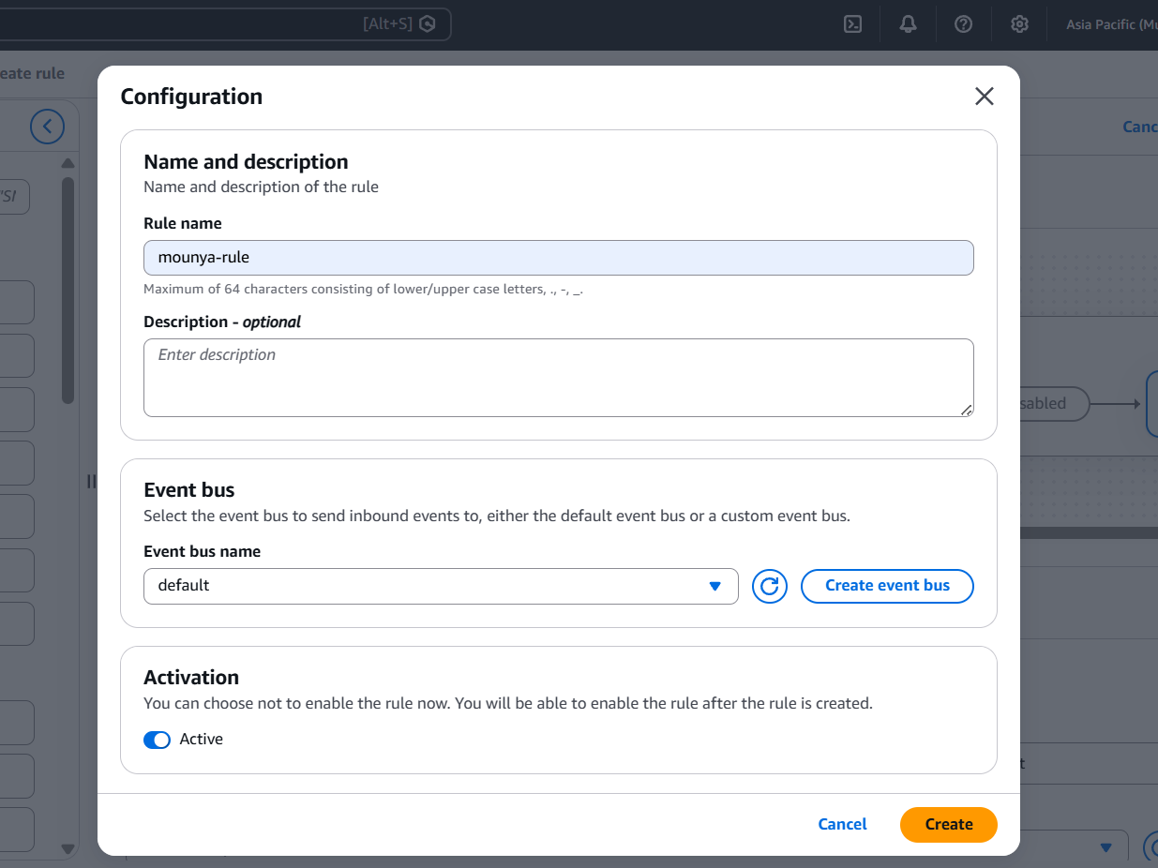

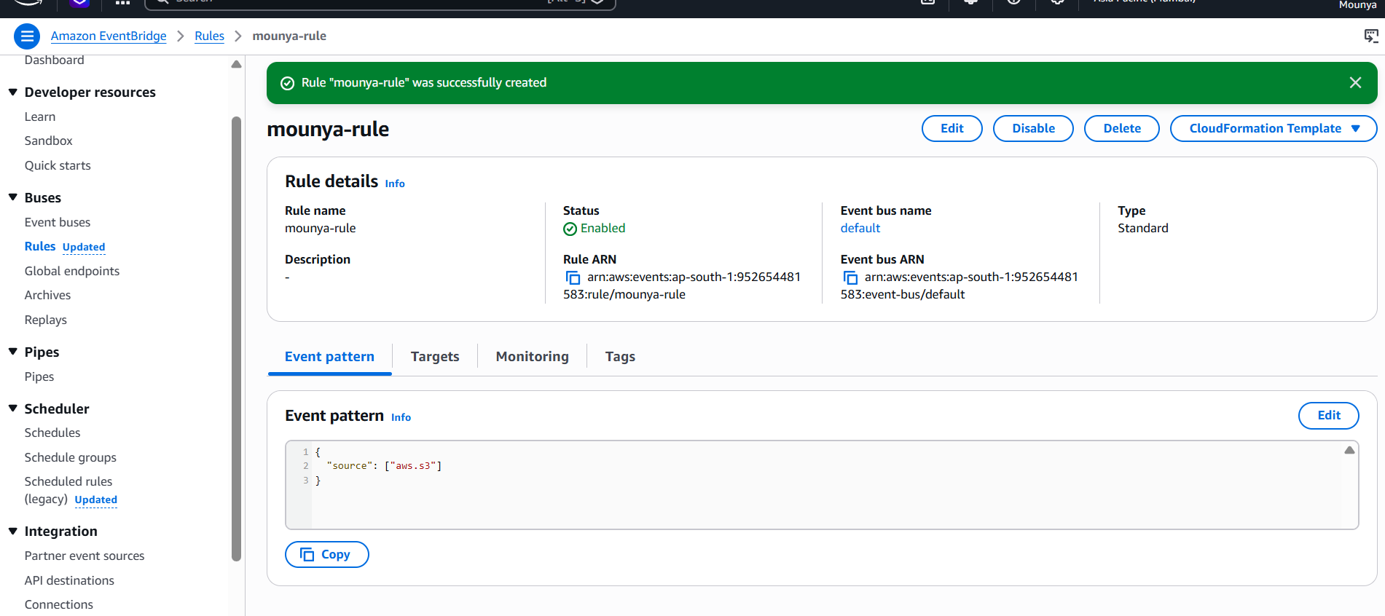

What happens after you click Create
- The rule will be created successfully ✅
- EventBridge will start listening for S3 events
- When any S3 bucket is created, the rule will:
  - Trigger
  - Send an event to SNS topic
  - SNS will send an email
Final step: TEST the rule (very important)
🔹 Create a new S3 bucket
- Go to S3
- Click Create bucket
- Give any new unique name
- Click Create

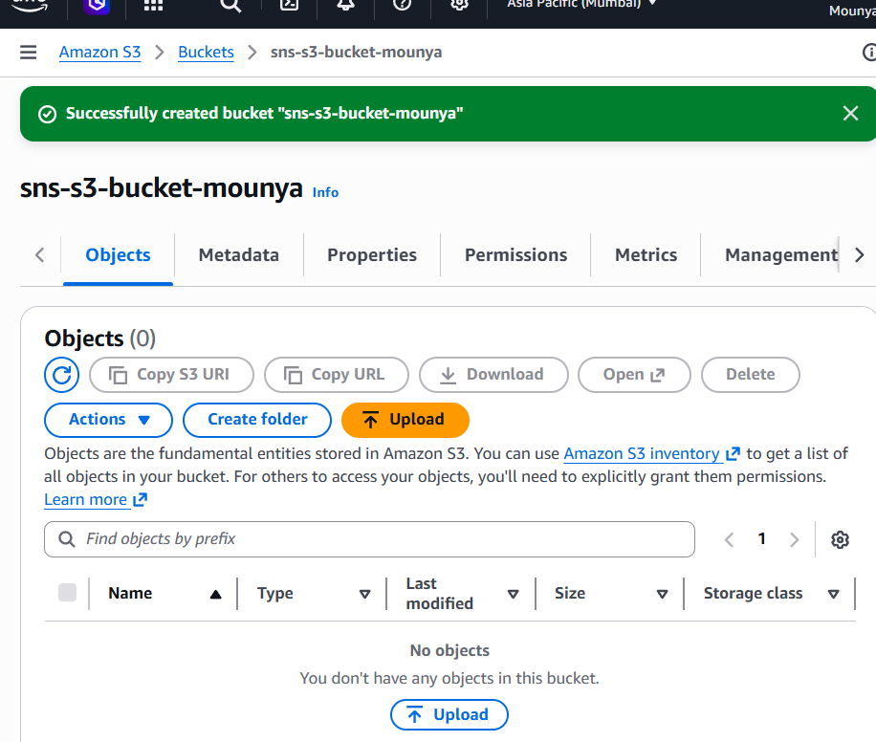

Check Your Email
Within 1–2 minutes, you should receive an email:
✅ Subject: S3 CreateBucket event
✅ Body: Details of bucket creation

